Treorchy Wind Fund
Application Form

Issued to: Public
Issued: 29.6.25
Status: Final v13
Filename: TWF Apln Form v13 290625.docx

treorchywindfund.co.uk
22 West View
Milborne Port
Sherborne
DT9 5EJ
Maerdy Windfarm Community Funds Ltd

What to Do
1. Scheme Guidance
Read the Scheme Guidance and Standard Terms and Conditions of a grant available on the fund website http://www.treorchywindfund.co.uk/.
2. A4 Bid Poster
Prepare a bid poster for the public to view.
3. Application Form
Complete this application form.
4. Send
Email us your application form, bid poster and supporting documents

Bid Poster
This is what the public will see, on the website and in the voting hall. There are lots of examples from previous years applicants on the fund website. Below is a guide.
Please be as creative as you wish, but make sure your bid poster is A4, portrait orientation and you address the items in the red bubbles. Please see the checklist at the end of this application form.

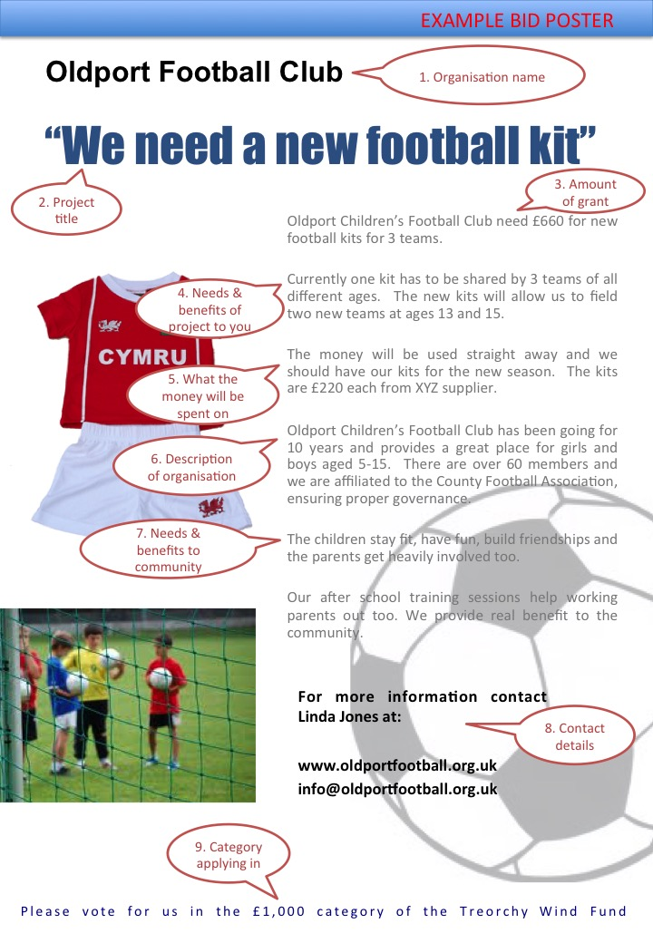

Application Form
This is a microsoft word document. Please complete all the input fields which will expand to fill your content. The rest of the document is protected to stop it being changed. Please note that if you click on somewhere other than an input field it will whiz you to the next available field; so scroll through the document to stop whizzing!
This section of the application form will be published. We will redact telephone numbers, emails and addresses. Should any other information be sensitive and you not wish it to be published, please advise us and we will redact it as agreed with you.

1 Name of Applicant
Organisation or Individual

2 How much?
How much are you applying for.

3 What on?
Please include a budget for all individual items that make up 10% or more of the total.

4 Benefits to you?

5 Wider benefits to the community?

6 Are you eligible to reclaim VAT?
If yes, we can advance the full amount including the VAT, but you must repay this to the Fund when you get the VAT refund, or you can apply for the amount less VAT.

7 Breakdown of cost
Please provide a breakdown of elements of the cost that are greater than £100. You are welcome to provide this as a seprate budget, or spreadsheet if easier. Additionally, you must provide copies of at least one third-party quote or weblink for every item over £100, and at least two quotes for any item over £1,000.

8 Other Funding - Are you seeking monies for the same project from elsewhere?
(You can do this but must repay to the Fund excess funding you receive from alternative sources.)

9 What alternative sources of funding have you considered and why are these not successful?

10 When will you spend the money?
Grants will be awarded in January 2026 and you have up to two years to spend the funding.

11 What other factors are necessary for grant expenditure to take place?
For example; there may be other funding you need, or a planning permission, etc.

12 How will the benefits of the grant be sustained after the funding has finished?
For example, if it is a capital item, is there ongoing cost such as maintenance or rent, or if operational does similar expenditure need to be found every year?

13 Any other information you wish to provide

Contact Details
Name of applicant
Individual or organisation, as per Section 2.1
Type of organistion
If applicant is organisation
Date of Birth
if applicant is individual
Address
Primary contact details
The person we will be dealing with
Full name
Position
If applicable for an organisation
Telephone
Email
Please note we only communicate by email and you must provide an email address
Address
Only if contact address is different to organisation address above
Secondary contact details
If you are an organisation please provide the details of the most senior official, if different to the primary contact
Full name
Position
Telephone
Email
Address
Only if contact address is different to organisation address above

Check list and Declaration
Bid Poster
Please confirm all the following are included in your Bid Poster:
A4 size
Portrait orientation
PDF ideally, JPEG or GIF will be accepted
Organisation Name
Project title
Amount of grant application
Needs and benefits of project to YOU
What the money will actually be spent on
Descriptionƒ of your organisation
Needs and benefits of project to COMMUNITY
Contact details for public enquiries
Grant category you are applying in
Poster is good quality resolution, especially images

Application Form
Every question is answered
Budget is provided
Copies of at least one third party quote for each cost element over £100 and two quotes for each cost element over £1,000.

Legal Declarations
I/We have read the Scheme Guidance (available on the website)
I/We have read the Standard Terms and Conditions of a grant (available on website) and confirm my/our willingness to agree to these should we be awarded a grant.
I am applying or I am authorised by the organisation named to submit this application.
The contents of the Application Form and Bid Poster are accurate and true.
I/We understand that any seriously misleading statements or knowingly withheld information could make our application invalid and we will be liable to repay any funds.
I/We agree with the data protection terms below.
I/We accept that provision of any grant is at the sole and absolute discretion of the administrators and the basis for any grant decision may change without prior notice and we will not legally challenge, pursue enforcement or make any legal claim against the Fund.

Signature
To fill in your signature you can either: i) Print this page; sign it, take a photo and send it in with the rest of the form, or ii) drop in a scanned image of your signature; or iii) save the word document as a PDF and then use software to put your signature on - Adobe Acrobat, or Apple Preview
Name
Your Position
Of organisation
For and on behalf of organisation
If applicable

That’s it

Send
Please send your
i) completed application form (either word document or PDF),
ii) supporting materials (budget, quotes, etc) and
iii) bid poster (PDF)
via email to enquiries@treorchywindfund.co.uk by 30th September 2025 at the latest.
We strongly recommend you submit as early as possible, and suggest at least 2 weeks before the deadline, so that we can advise you of any failings in your application and there is time to address these and resubmit. If your application is not valid by 30th September 2025 then we cannot accept it.
If absolutely necessary we will accept postal versions to: Treorchy Wind Fund, 22 West View, Milborne Port, Sherborne, DT9 5EJ, but all communication by us will be by email.

What next?
We will acknowledge receipt of your application within one week by email. If you have not heard from us please make contact to ensure your application has been received.

Data protection
Please see our data policy below.
If you have applied for, or hold a grant with us, we will use the information you give us during assessment and during the lifetime of any funding to administer and analyse grants and for our own research purposes.
Unless speciifally agreed otherwise with you we may give copies of all or some of this information to individuals and organisations we consult when assessing applications, administering the programme, monitoring funding and evaluating funding processes and impacts. These organisations may include accountants, external evaluators and other organisations or groups involved in delivering the project.
We may also share information with government or other organisations and individuals with a legitimate interest in grants or specific funding programmes, or for the prevention and detection of crime.
The Treorchy Wind Fund is subject to a public vote and therefore involves general public publicity. We will not share your personal details on the declaration page, however, if there is any other information in this application form or in subsequent correspondence that you do not wish to be made available to the general public then you must advise us.
We might use personal information provided by you in order to conduct appropriate identity checks. Personal information you provide may be disclosed to a credit reference or fraud prevention agency, which may keep a record of that information. If false or inaccurate information is provided in a funding application and fraud is identified, details will be passed to fraud prevention agencies to prevent fraud and money laundering.

